Homework Menu: Leif Erikson!
 | Week 1 | Week 2 | Week 3 | Week 4 | Week 5 | Week 6 | Week 7
2 Points  (Optional)  Can be completed in any order! | Could you complete these homework challenges?
 | Activity 1  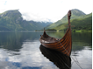  What can you find out about Norway? When did the Vikings live here? Make a Viking fact file! | Activity 2  What are the worst natural disasters of all time? Where did they happen? Make a top 10 list! | Activity 3  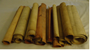  Using the Viking runes you’ve learnt in class, create some ancient Viking scrolls for your classmates to decode! | Activity 4  Beware of the Arctic foxes upon your arrival in Vinland. Can you make a paper plate Arctic Fox?  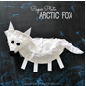 | Activity 5  Bake some rye or seeded bread to keep you nourished during your forest trek! | Activity 6  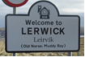  Many places were named during Anglo-Saxon times. Can you find out the names of villages, towns and cities which were named during this period? | Activity 7  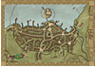  Produce a map to go alongside your Viking village and explain where everything is located!
Date Completed
Home Comments
3 Points  (Optional)  Can be completed in any order! | Activity 1  Design and make a Viking helmet – this will help protect you on your voyages at sea! | Activity 2  Create a live news report about the deadly cyclone that has hit your ship!  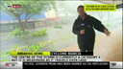 | Activity 3  Can you make your own little Viking? You could sew him together if you REALLY want a challenge! | Activity 4  The Icebergs that the Vikings encountered would be very different from the Icebergs of today – research why and how global warming is altering our landscape! | Activity 5  Produce a collage of the forest in which you have arrived – use as many different materials as possible – you could even use real leaves and twigs! | Activity 6  Build your own model Viking village! What will it contain? How will you build the structures?  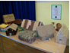 | Activity 7  Use minecraft to build your village digitally – ensure that your settlement is close to water and you have somewhere to keep the long ships!  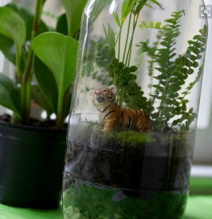
Date Completed
Home Comments

